Study 1
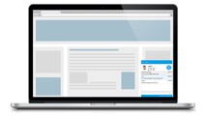



Gave informed consent


Asked to engage in 10-minute chat about anything they wanted with anonymous person.

Log on to Facebook profile so researcher can take a screenshot.
Completed questionnaire on
psychological factors (Social anxiety, self-esteem, personality, self-monitoring), emoticon use & perception of privacy.

e.g. on average how many emoticons do you use in text messages, Facebook and in emails per week?

